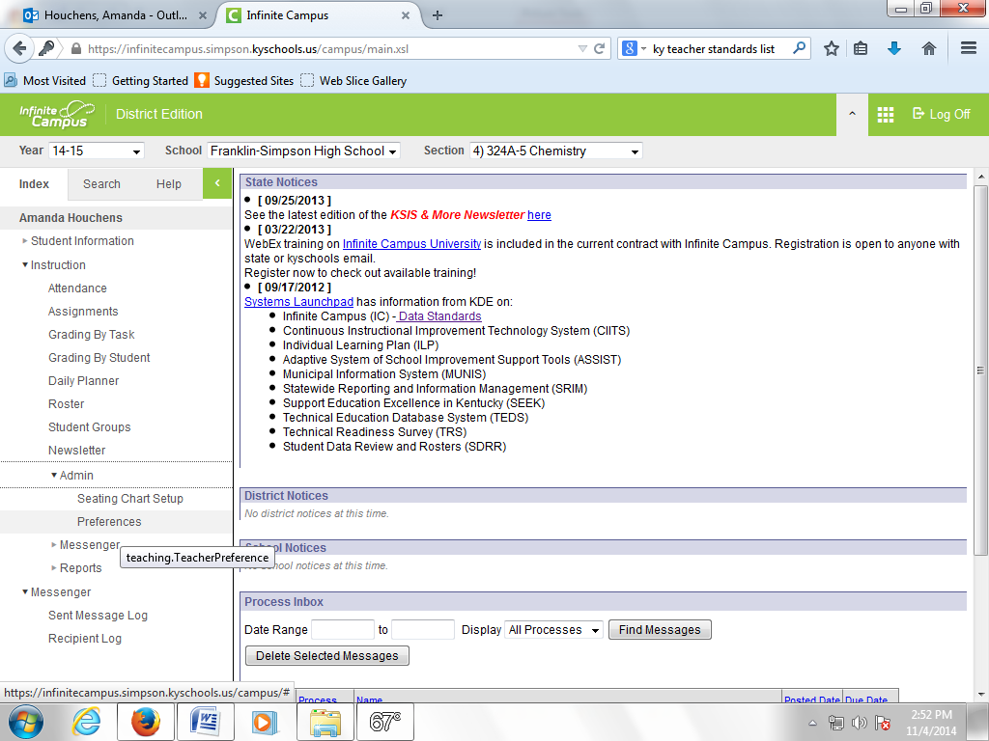
Click on Preferences under the Admin link.
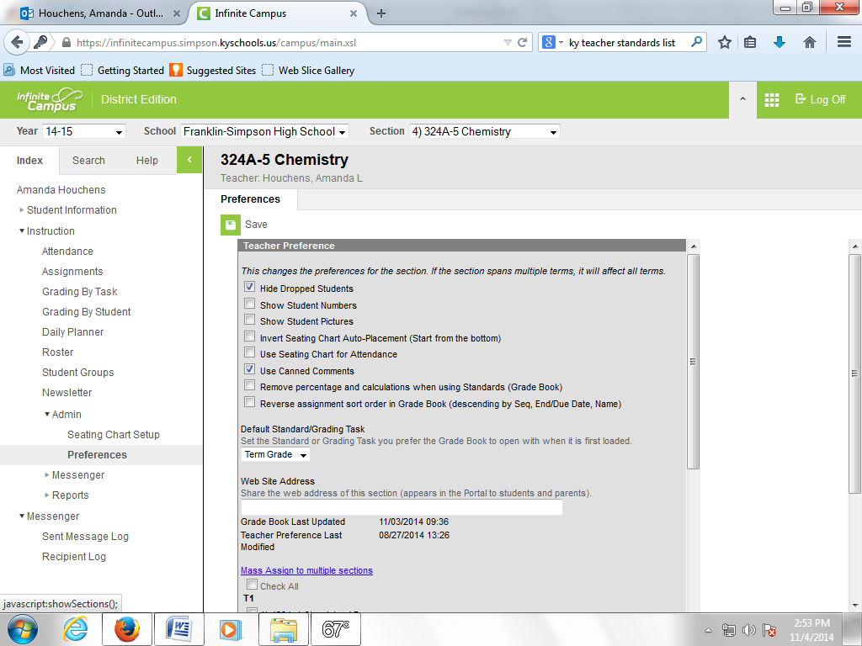
Check the boxes next to “Hide Dropped Students” and “Use Canned Comments.” Then click the blue link “Mass Assign to Multiple Sections.”) You can then check the box next to “Check All” and then click “Save” at the top.

Next you will need to determine your GT students. You can do this by looking at your roster.
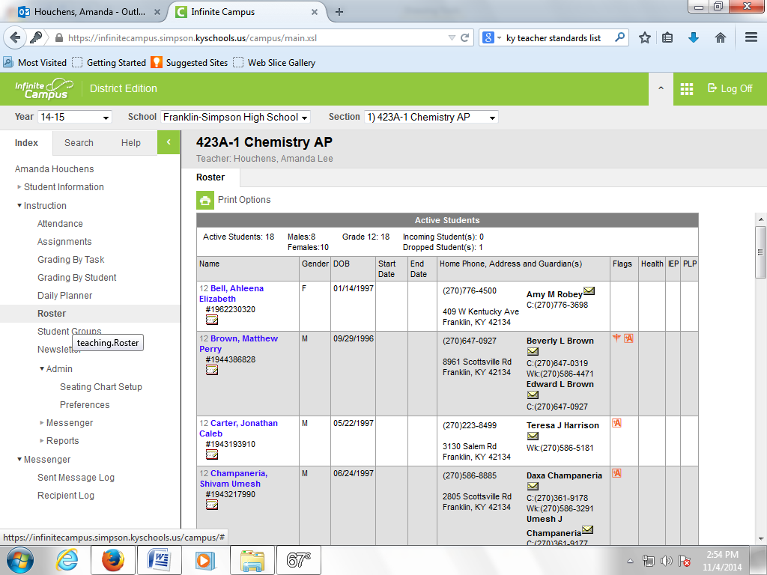
Select the class from the drop down menu at the top. Click the link “Roster” at the left. GT kids are identified by the red A+ symbol.

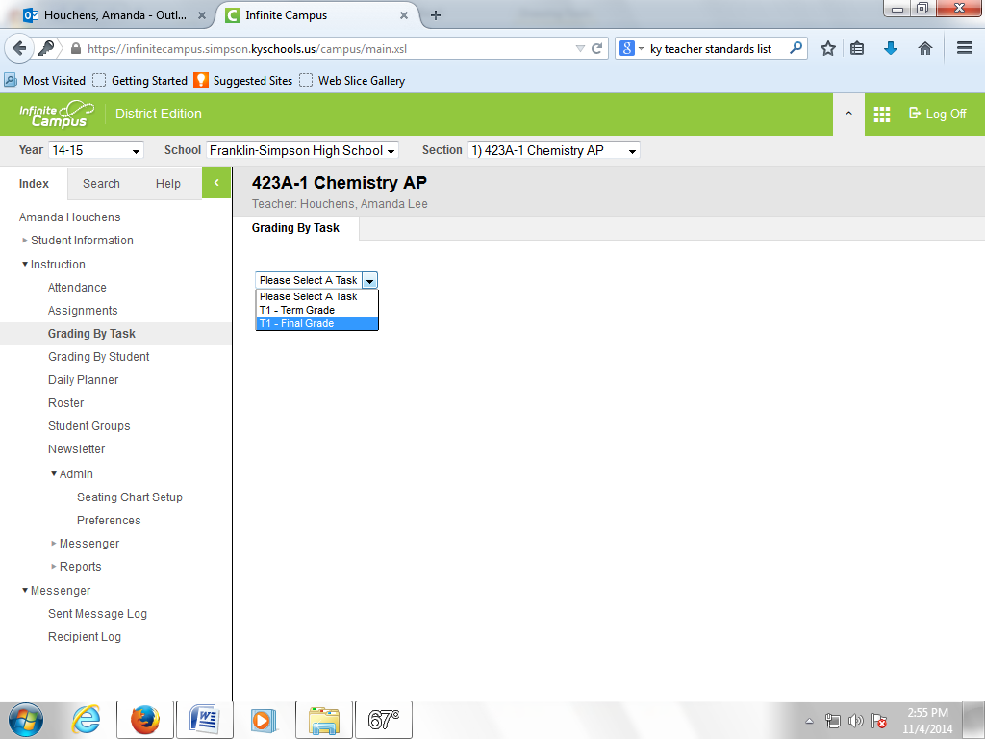
Once you have identified all of your GT students, click the “grading by task” link on the left. Then select “Final Grade” from the drop down box.
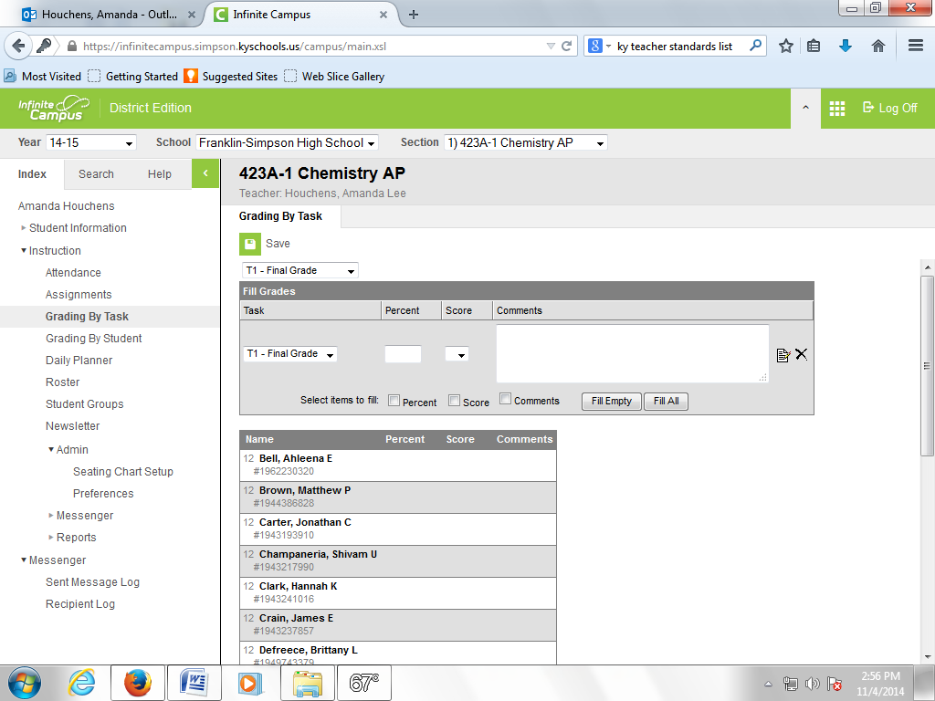
Because the grading window is not currently open (as I make this guide) this screen looks a little different. Next to each student you should have a white comments box like the large one currently at the top of the screen in this image. Notice the small piece of paper and pencil icon.
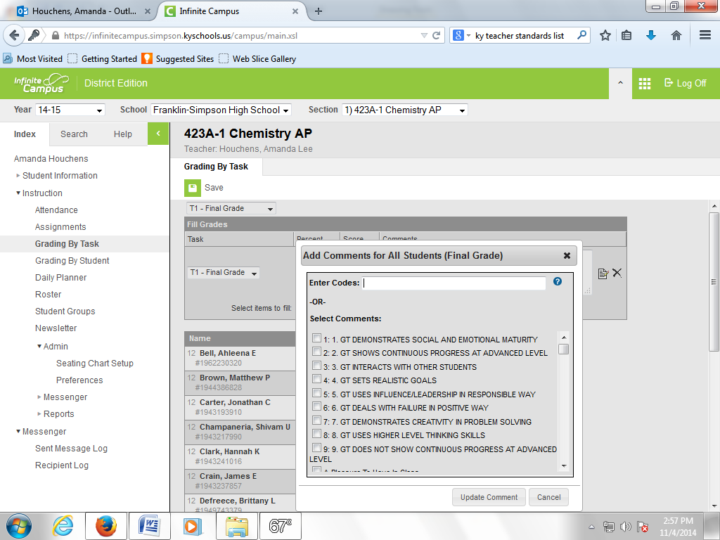
You will need to click on the icon next to the comments box for EACH STUDENT. (If you use the one at the top, it will post the same comment for ALL students. This is NOT the goal.) You will then need to select the appropriate comment(s) and then click update comment.
NOTE: you can use these comments for all students, not just GT. (Just make sure you only use the ones labeled GT for GT kids.)
Then click “Save” at the top.
Congratulations, you can now use canned comments and make Mrs. Reetzke’s life a little easier!

