- Select the Practice ACT test you need forms for.
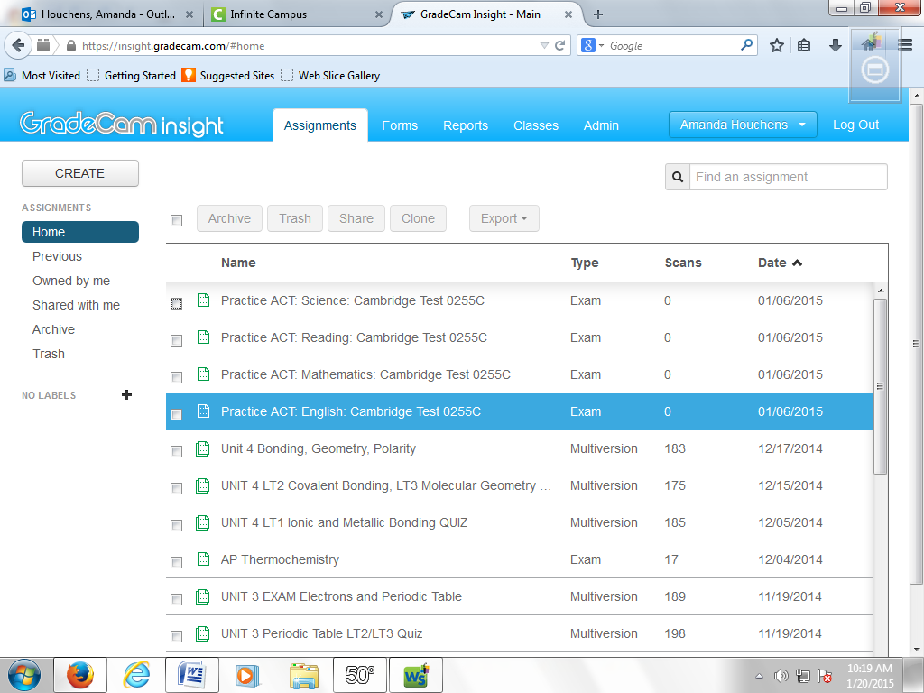
- Click “KEY.” Then, click “FORMS.” (NOT THE FORMS TAB ON TOP!)
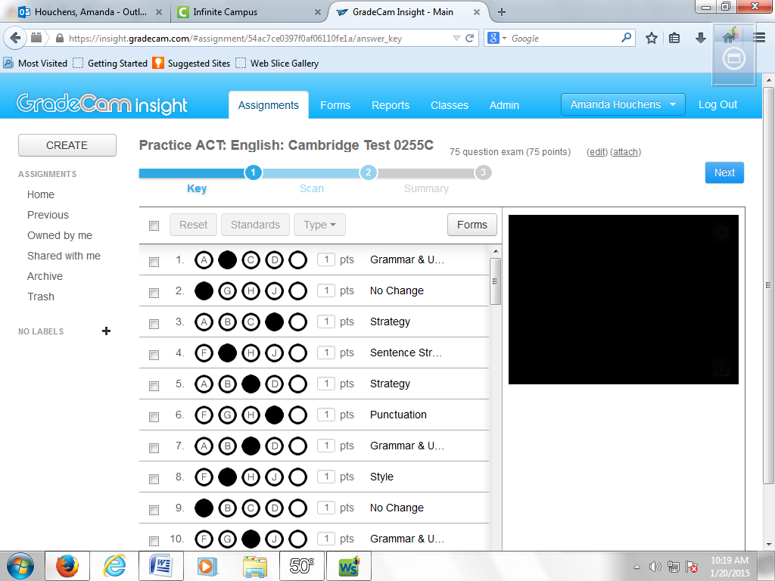

- Select you Academic Time from the drop down menu.
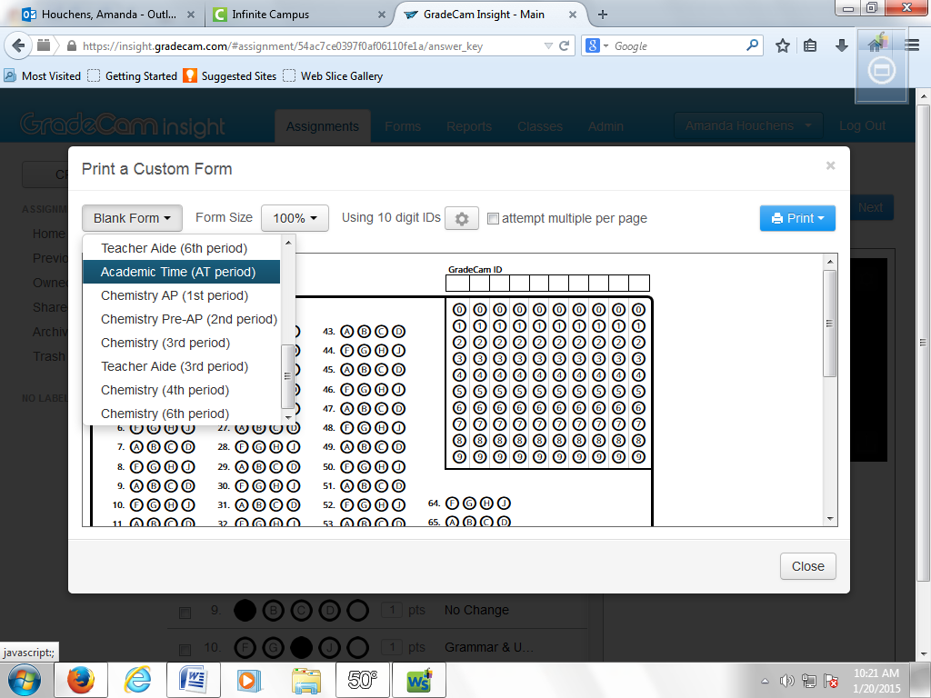

- Then select “to PDF” from the drop down menu. Once this opens, you can print it or save it to send to be printed.
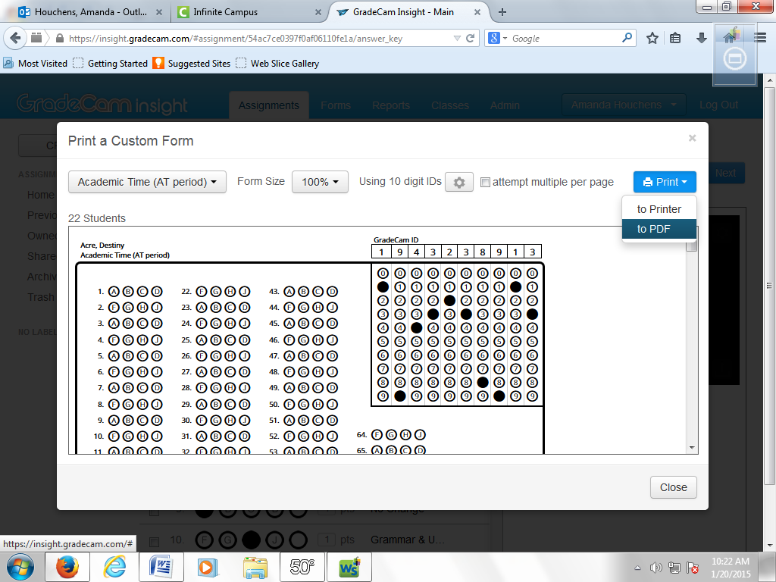
TA DA! You’re done!

