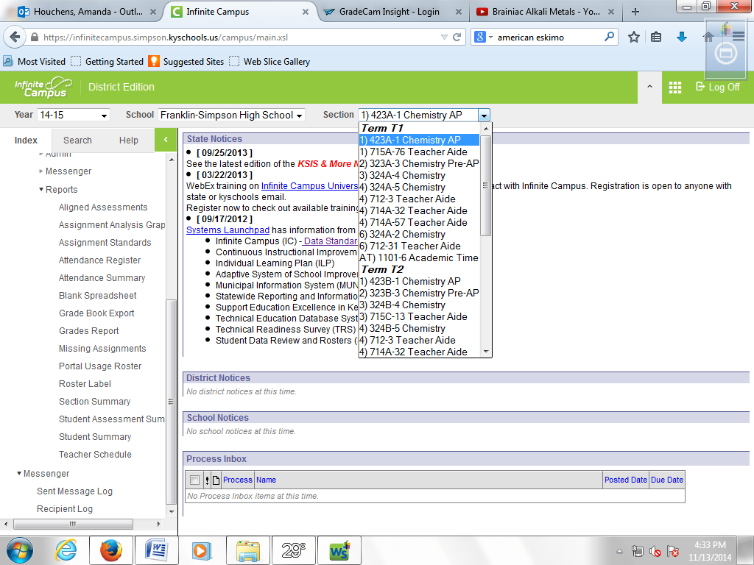
Select your class from the dropdown menu that you wish to print.
Then, click on “section summary” under “reports.”
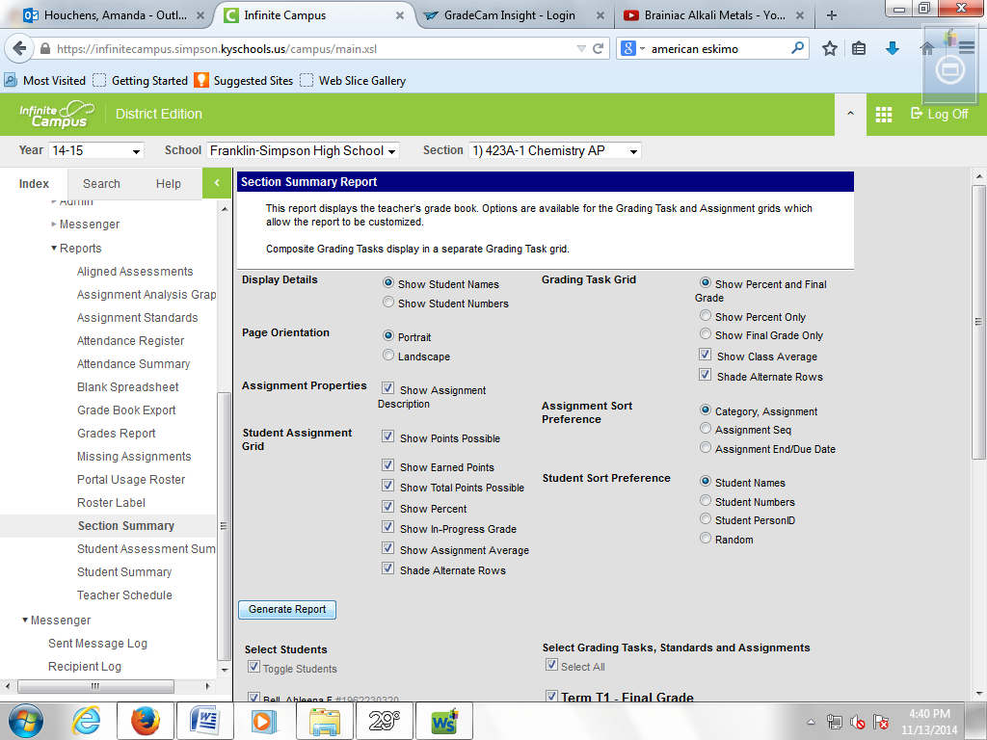
Select “generate report.” (I don’t change any of the defaults. You can play with them as you wish.)
When the next window opens, print it.
Repeat for each class, each trimester.

