This only works for non-EOC courses, or so I’ve been told, so I apologize in advance if this does you no good.
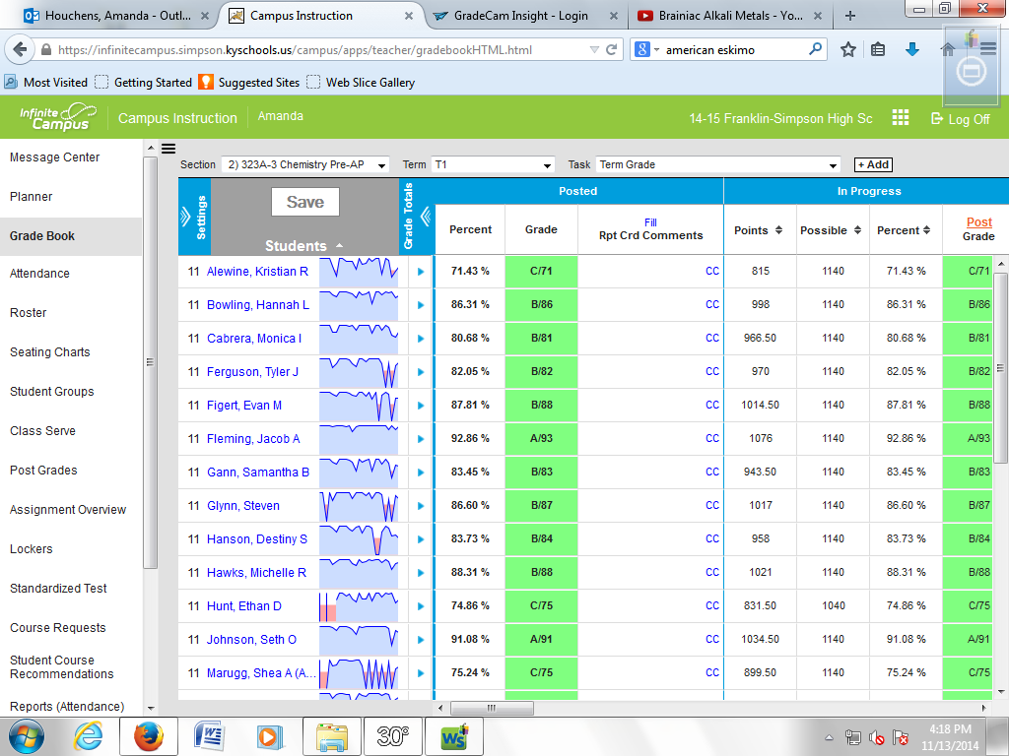
From your grade book view, click post.
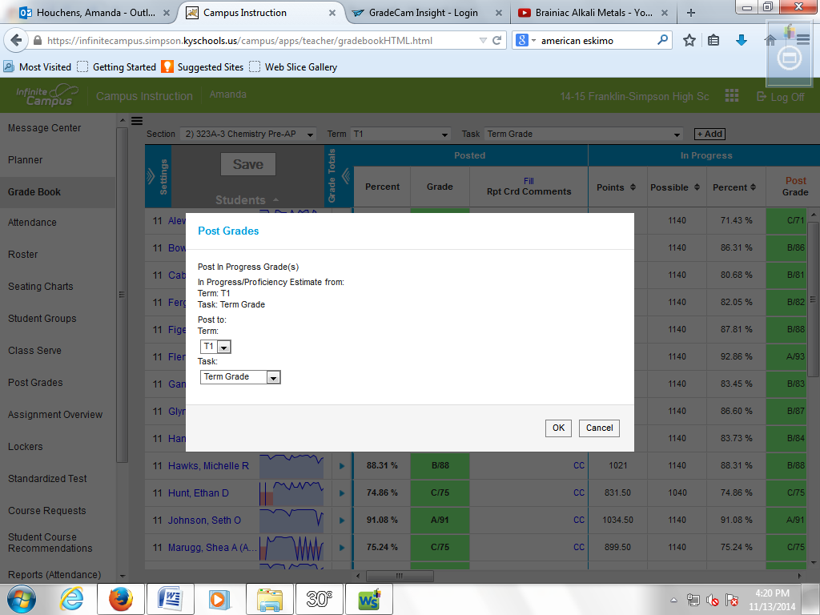
Make sure “term grade” is selected. Click “OK.”
Then, you will get a pop-up that says grades will post upon save. Click “OK.”
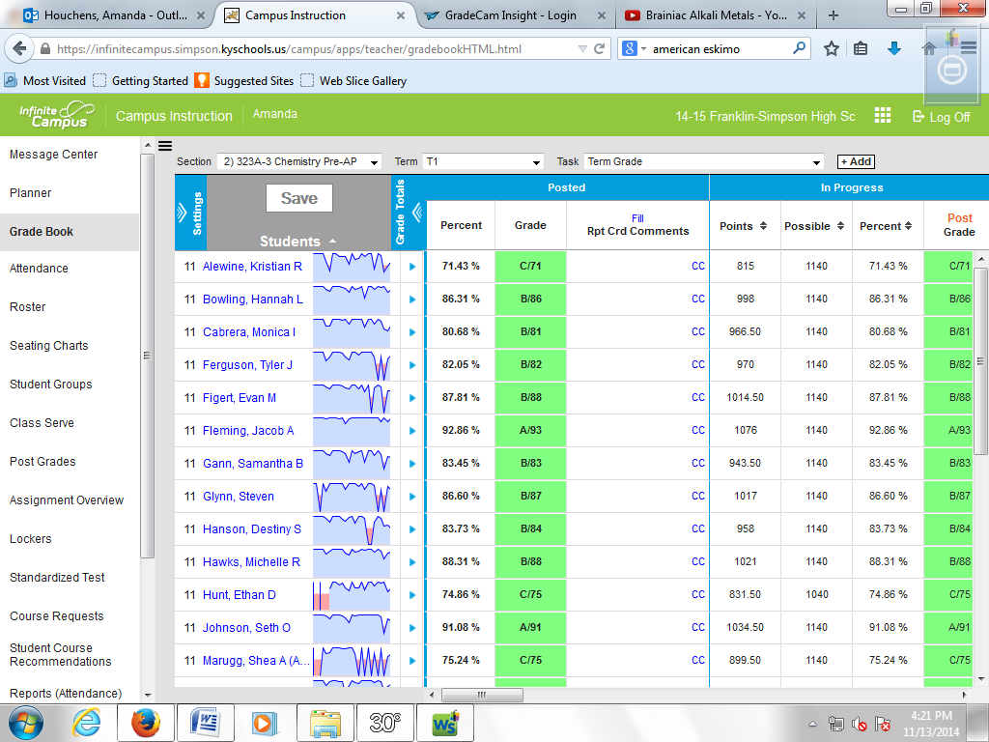
Click “save.”
Then click “post” again.
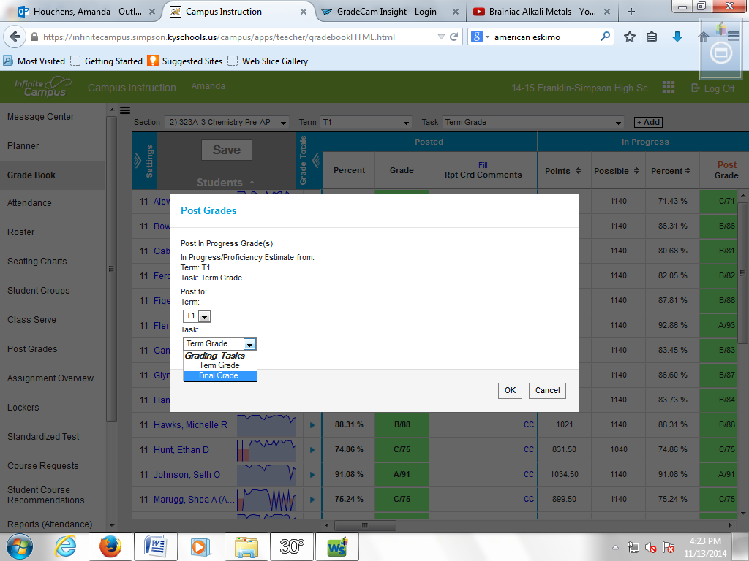
This time, select “final grade” from the drop down menu. Then, click “OK.”
You will get another pop-up indicating grades will post upon saving. Click “OK.”
Then click “save.”

DISCLAIMER: There are several other ways to accomplish this task, but this is the way that I know how to do it and it works. If you have another way that works, feel free to share it. Infinite Campus has definitely made this whole “posting grades” and “using canned comments” thing a higher level thinking task by having so many right ways to get to the correct answer!

