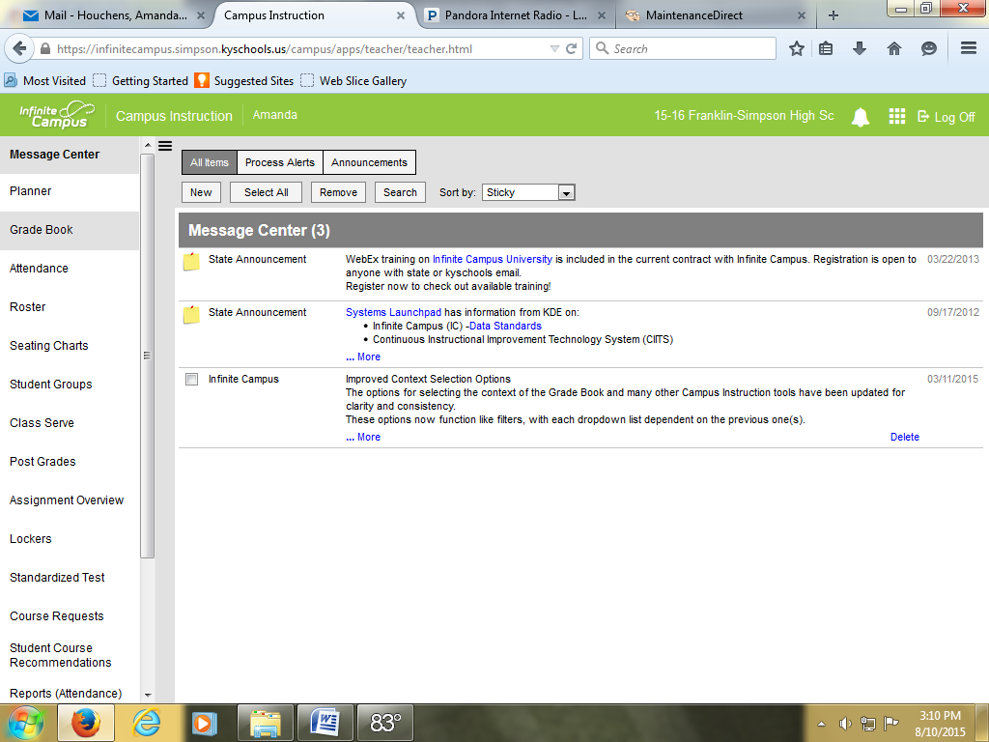
Click “Grade Book.”
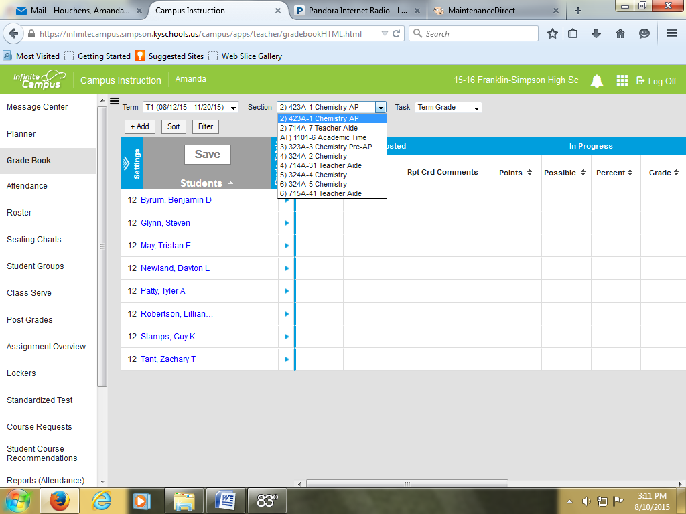
Select your course from the drop down menu. Make sure T1 is selected in the Term drop down menu.
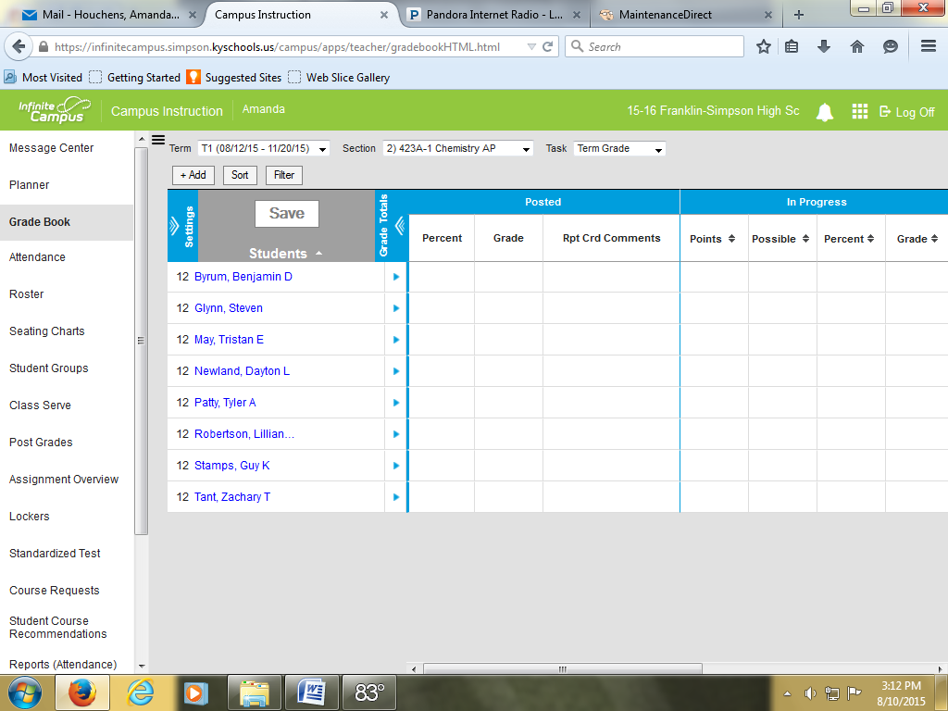
Click “Settings.”
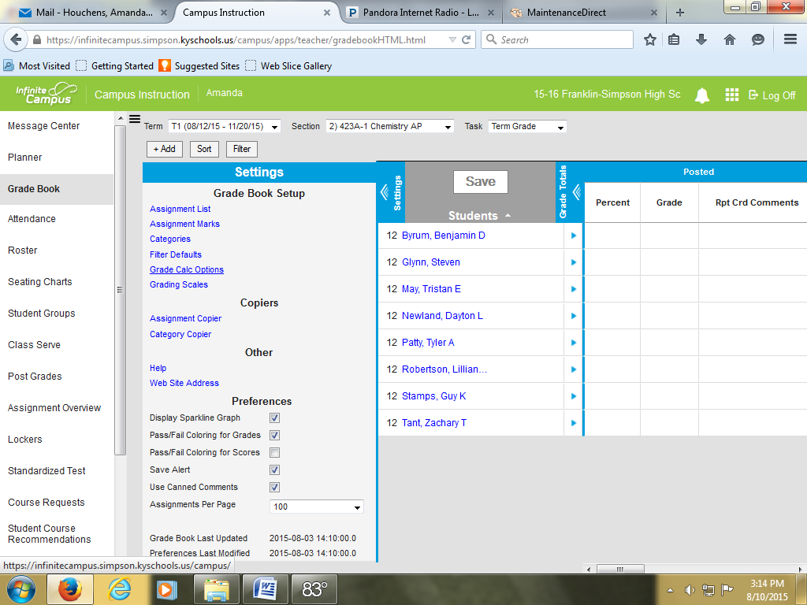
Click “Grade Calc Options.”
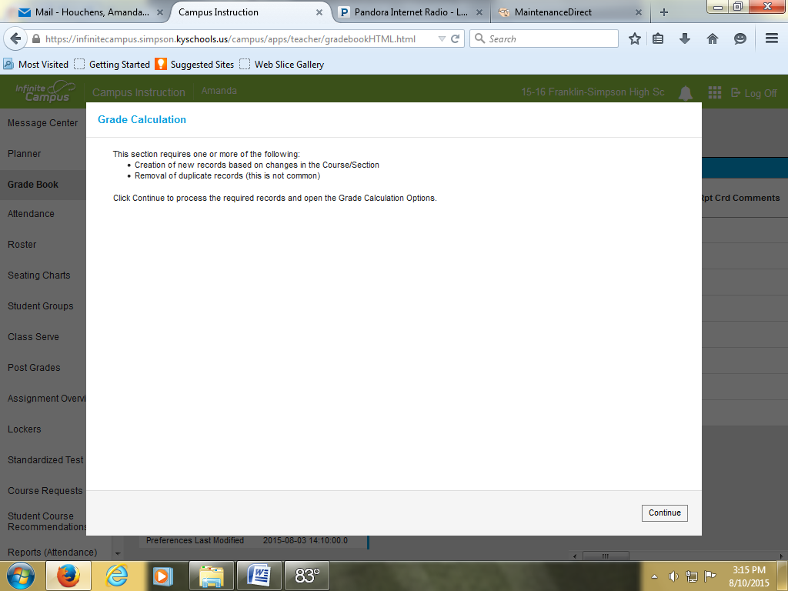
If you see this screen, click “Continue.”
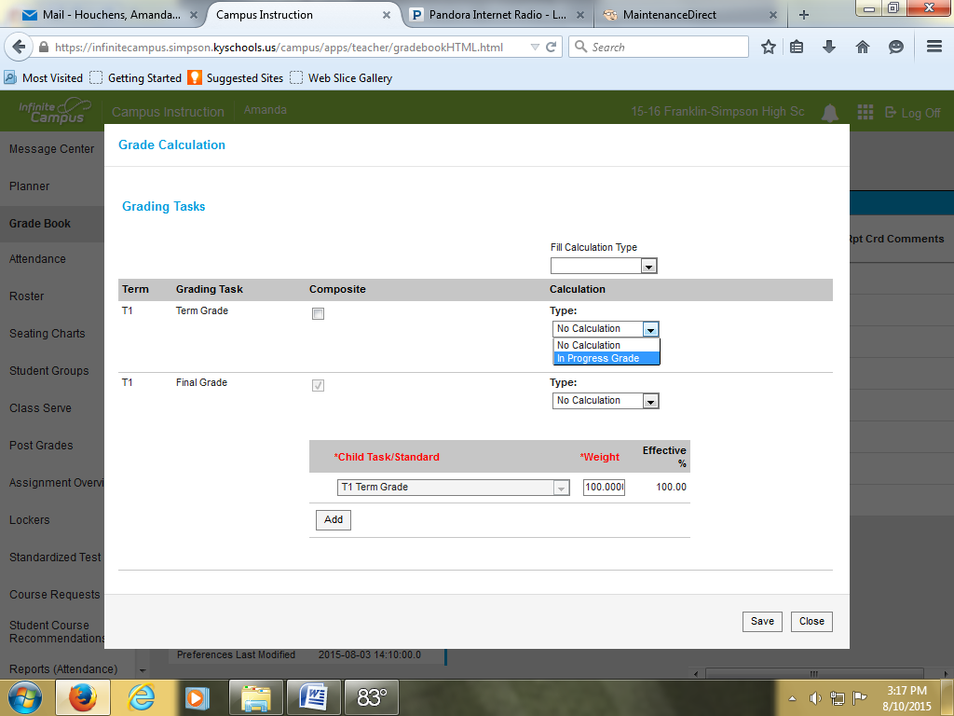
Select “In Progress Grade” from the drop down menu in the “Term Grade” Row.
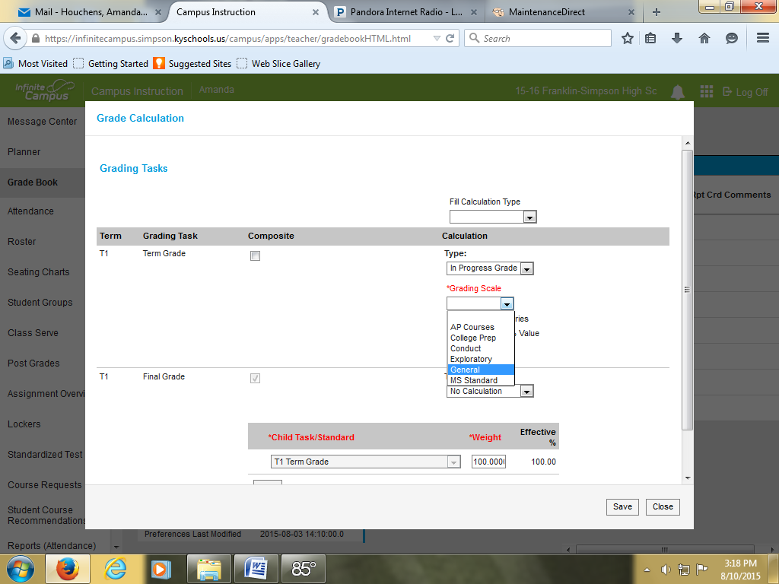
Select “General” from the drop down menu for grading scale. **If this is for an AP class, select “AP Courses.”
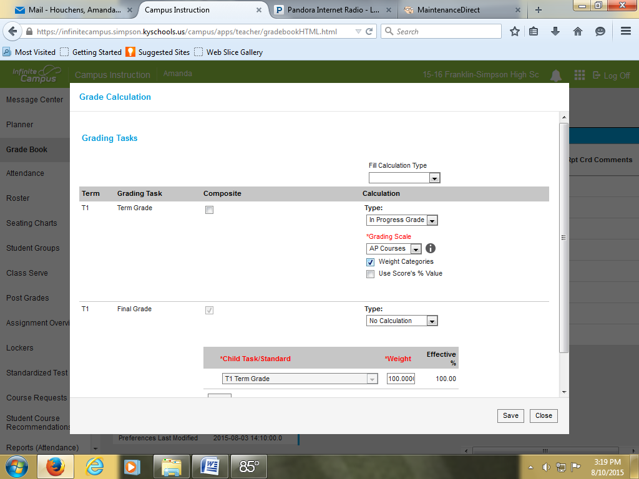
If you are going to use categories and weight them, check the box next to “Weight Categories.”
Click “Save.”
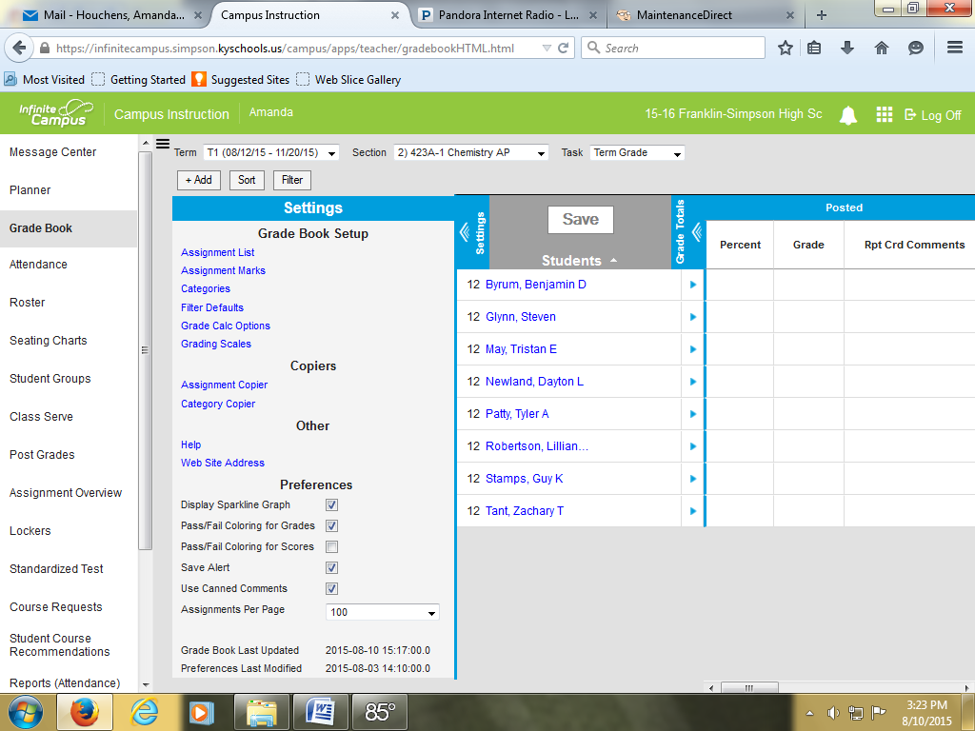
Click on what “Preferences” you would like to use. I strongly recommend you use “Save Alert” and “Use Canned Comments.” “Pass/ Fail Coloring for GRADES” is also very helpful in giving you a very quick visual as to who is passing (green) and who is failing (red) your class (unless, of course, you are red/ green deficient. Sorry!!) The “Sparkline Graph” is nice to visualize a student’s grade over time.

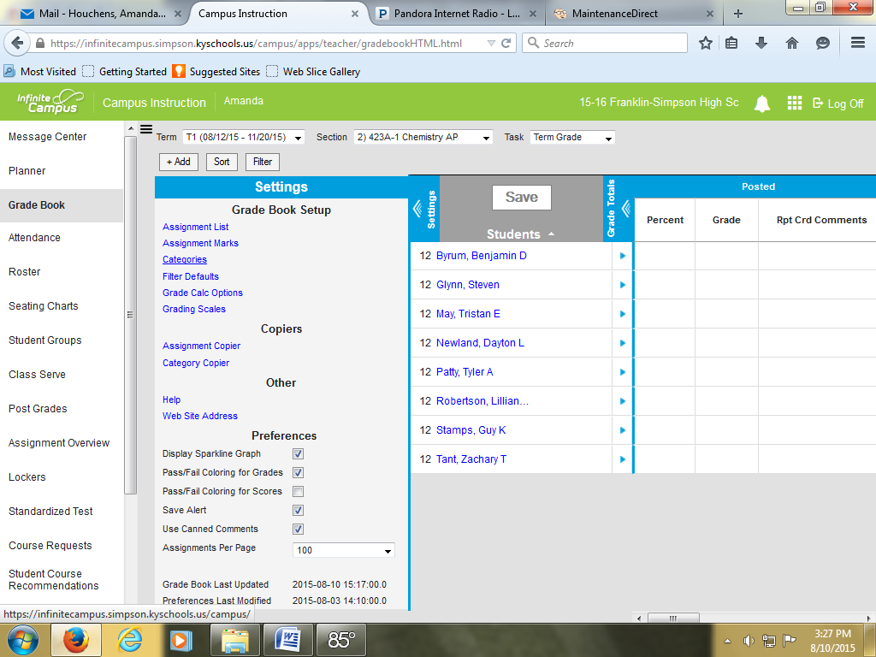
Now, to add categories in your grade book, click “Categories.”
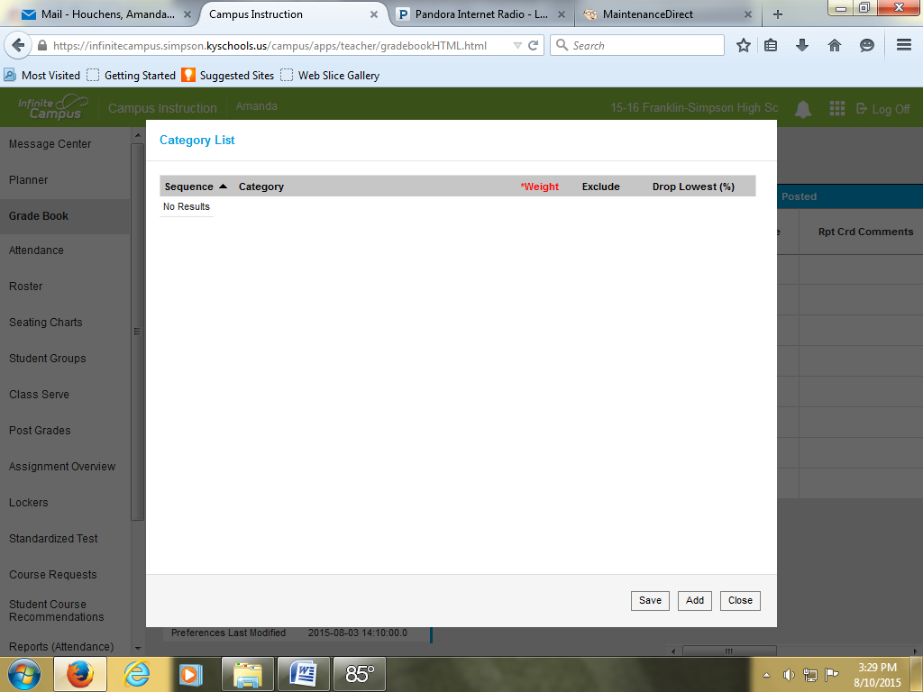
Click “Add.”
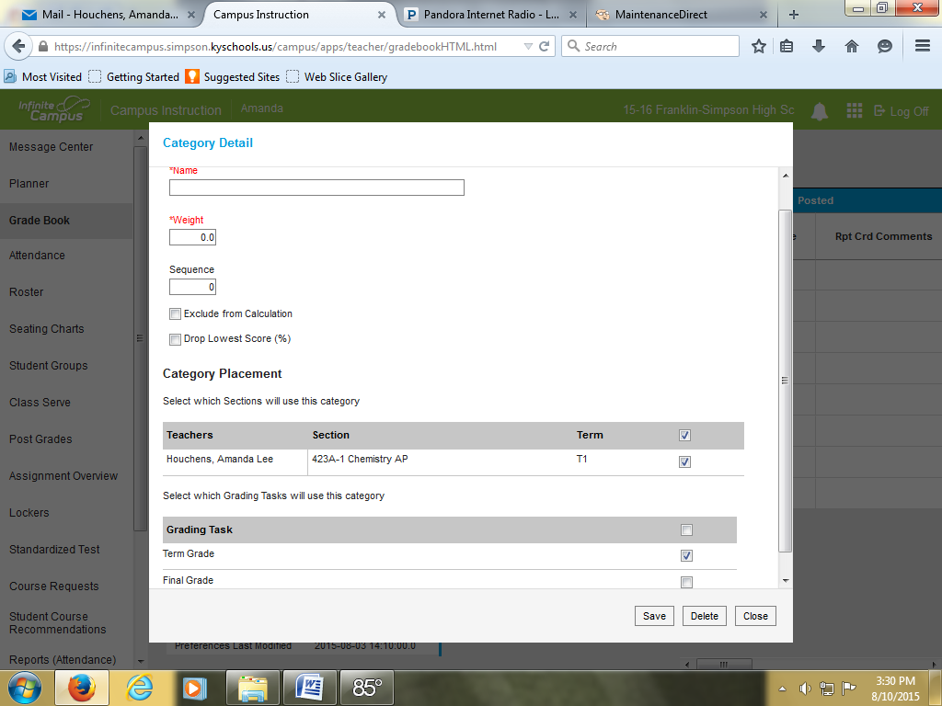
Give your category a name in the “Name” box.
If you are weighting categories, assign the category a weight in the “Weight” box.
If you are doing Standards Based Grading and this is a category for homework that you do not want included in the students’ grades, click “Exclude From Calculation” and leave the weight as 0.0.
Click the box next to T1 in the “Category Placement” row.
Click the box next to “Term Grade” in the “Grading Task” row.
Click “Save.”
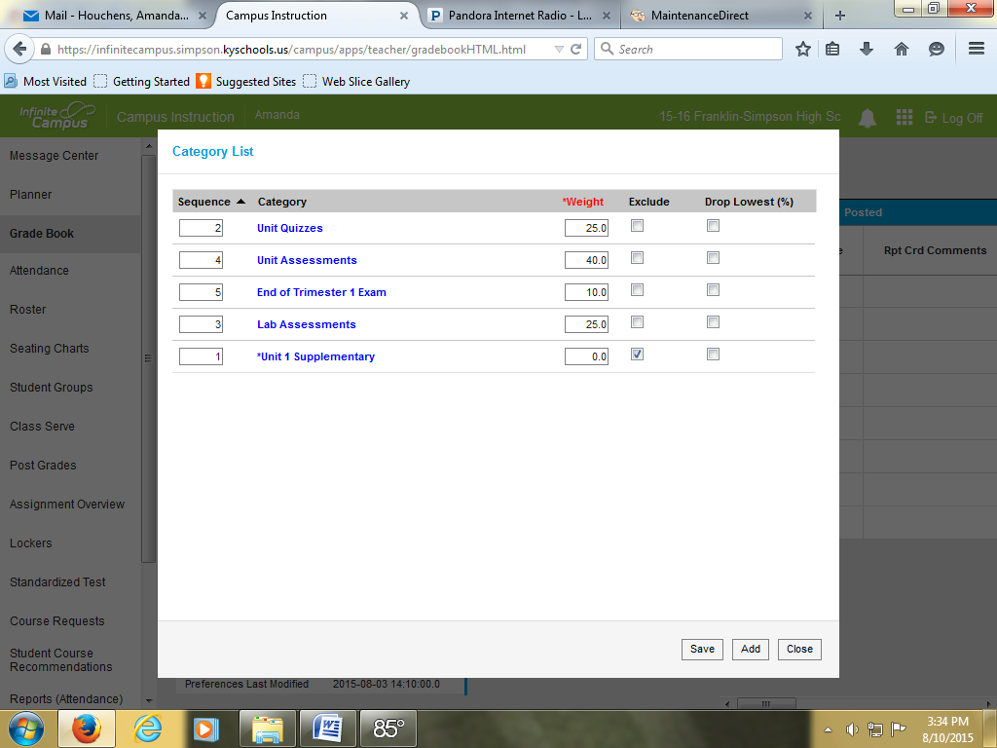
Continue this process until you have added all the categories you want.
When finished, click “Save” and “Close.”
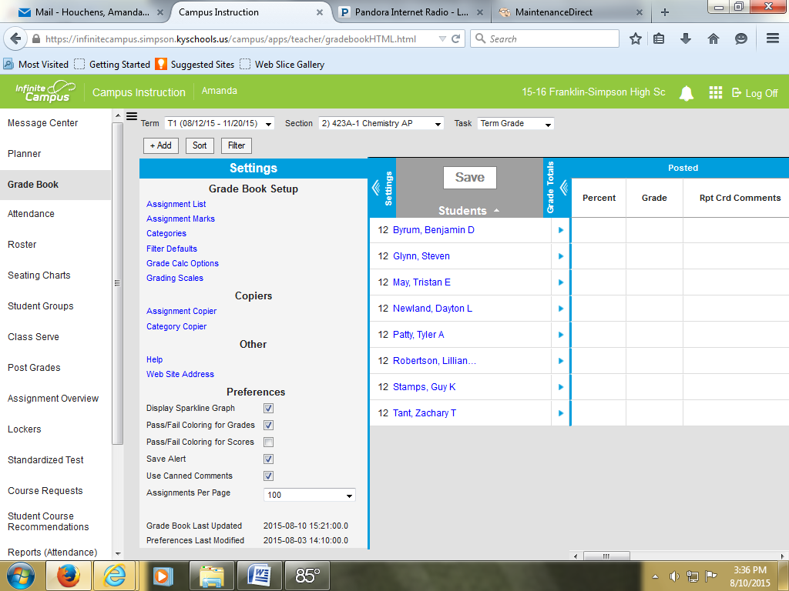
To add assignments, click “+Add.”
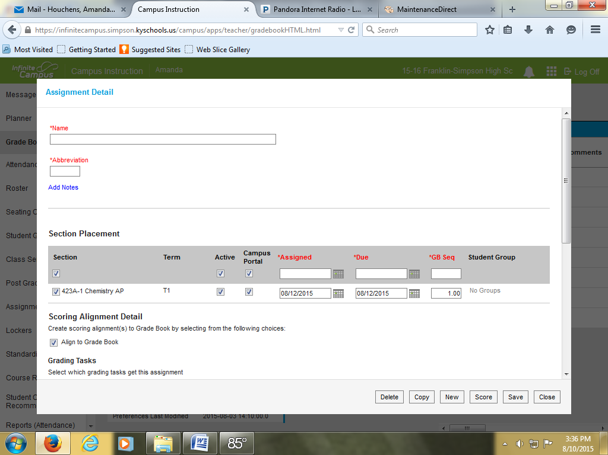
Give the assignment a name in the “Name” box.
Give the assignment an abbreviation in the “Abbreviation” box.
Click what sections you want to have the assignment assigned to it in the “Section Placement” row. (My screen shot only shows one section of Chemistry AP because I only teach one section. Those of you who have multiple sections of a class can mass assign here.
Select an “Assigned” and “Due” date.
Scroll down.
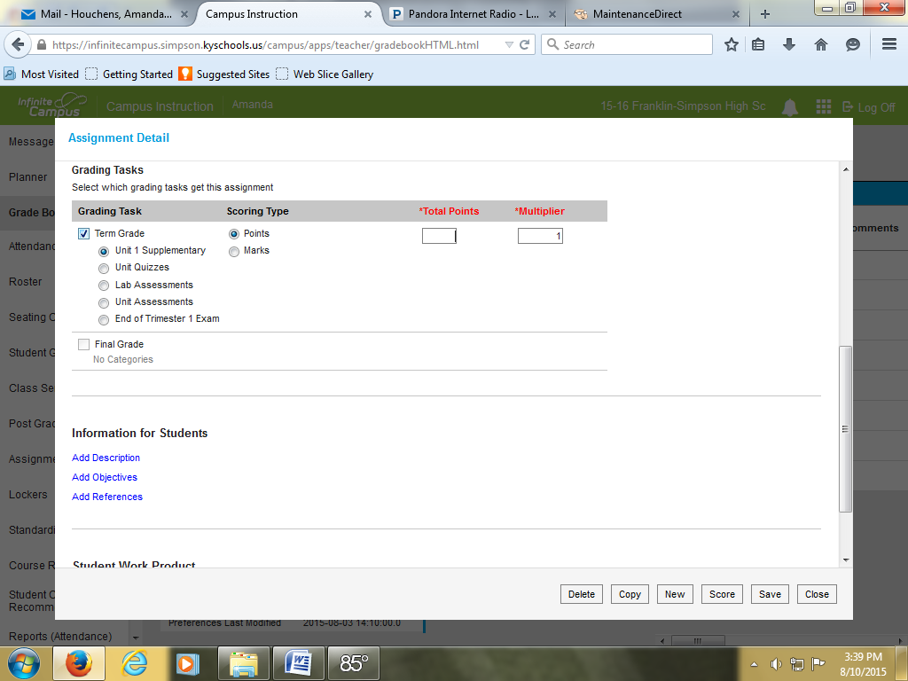
Select the box next to “Term Grade” under the “Grading Task” heading.
Select what category you want the assignment to go under.
Assign the total point value of the assignment in the “Total Points” box.
Click “Save.”
Repeat as needed to add assignments.

