First, log in to grade cam and select “CREATE.”
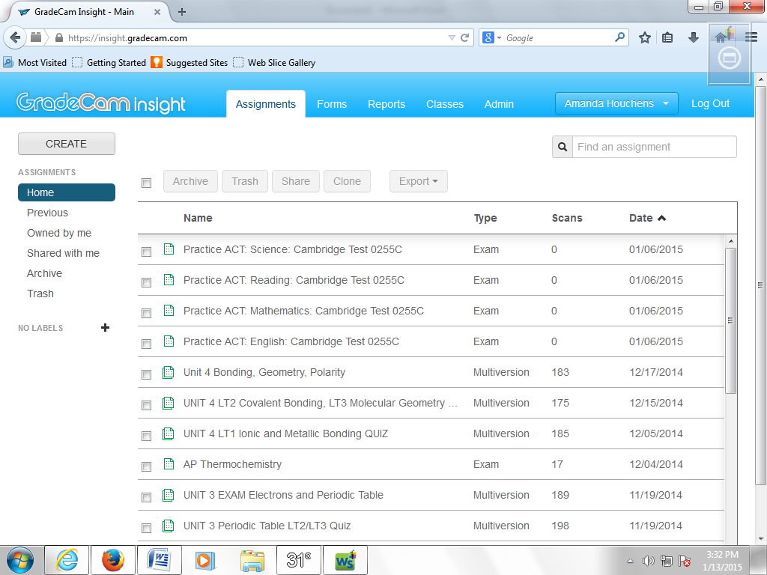

Then, give your test a name, select the assignment type (“Exam” is default, but you can also select “Multiple Version Exam” if you need multiple version to discourage students from cheating), and enter the number of questions. You can also edit the date and give it a description if you wish.
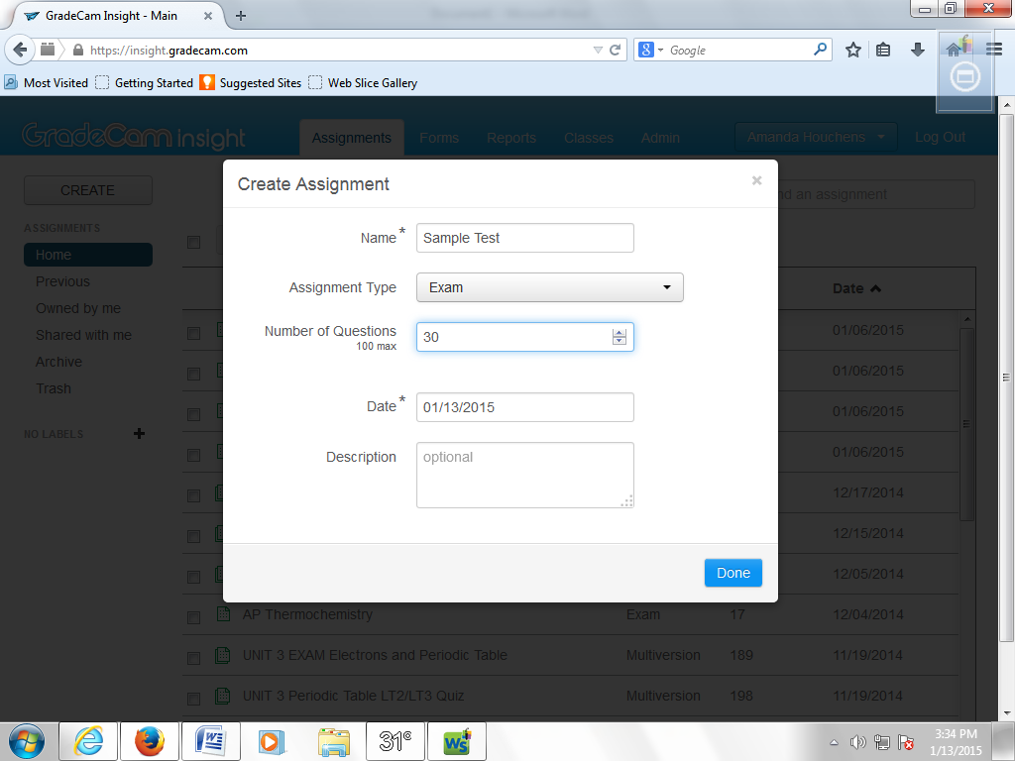

If you need to change the question type (multiple choice, T/F, Rubric, ABCDE/ FGHJK, etc.) do that now. Make sure you select the boxes next to the questions you wish to change. If you want to make an “ACT like” test, make the odd questions ABCDE and the even questions FGHJK.
***********This step is optional.***********
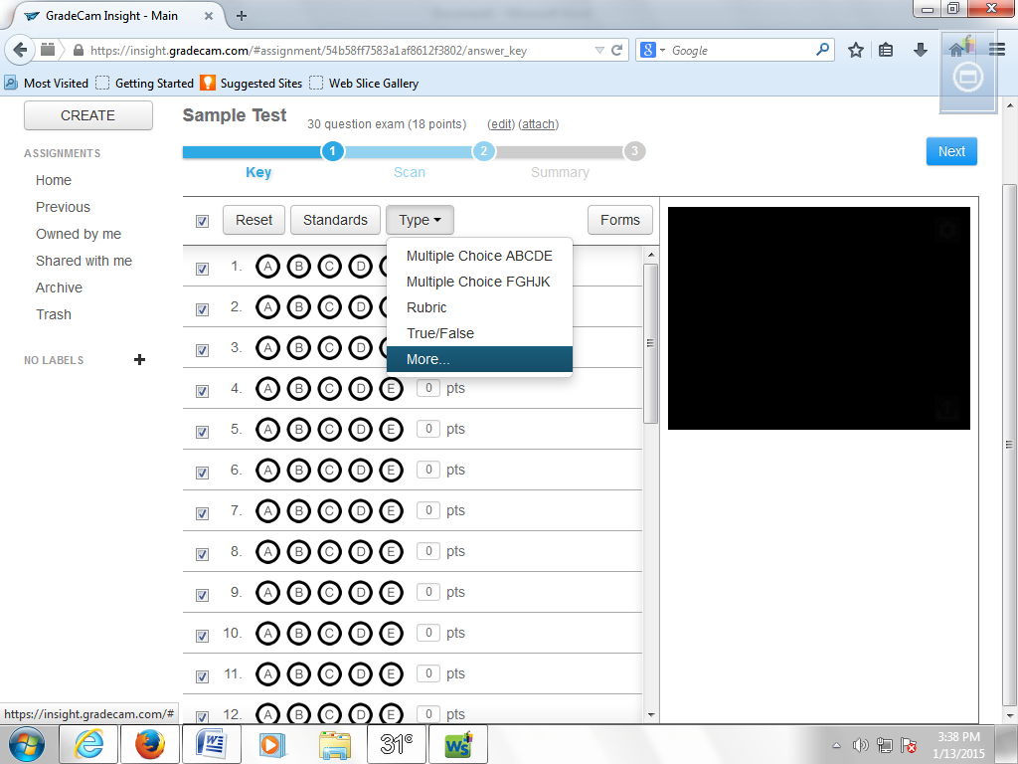

Now, mark your key.
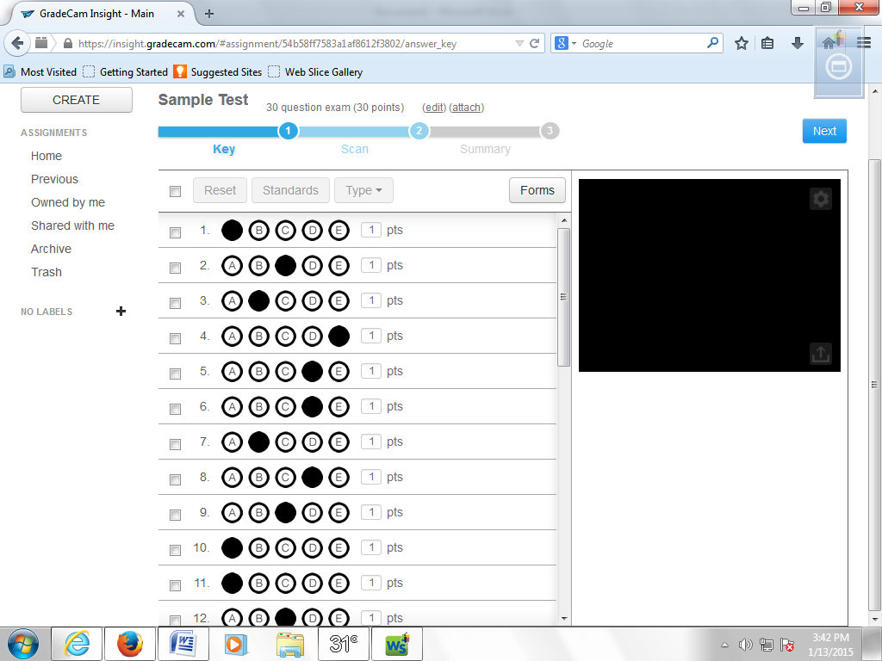

Now for aligning the standards…
You must align one standard at a time.
Select the questions you wish to align by clicking the boxes next to the question numbers and click “Standards.”
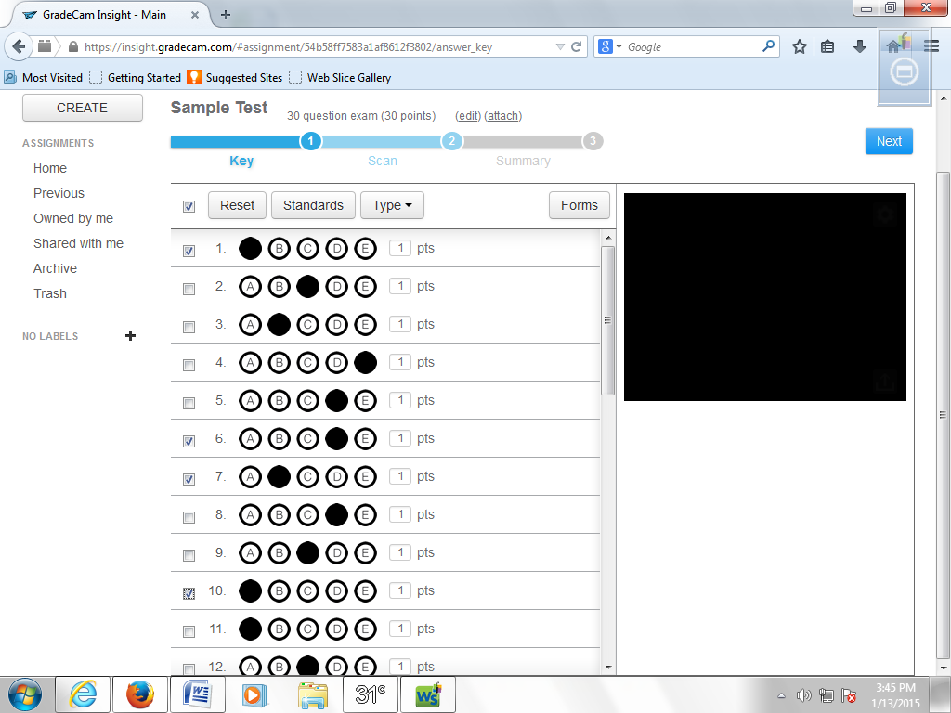

Select your “Standard Source,” Subject,” and “Grade” from the drop down menus. You can even enter specific search terms to help narrow your results. Scroll through the results and click align next to the standard you want to align the questions to.
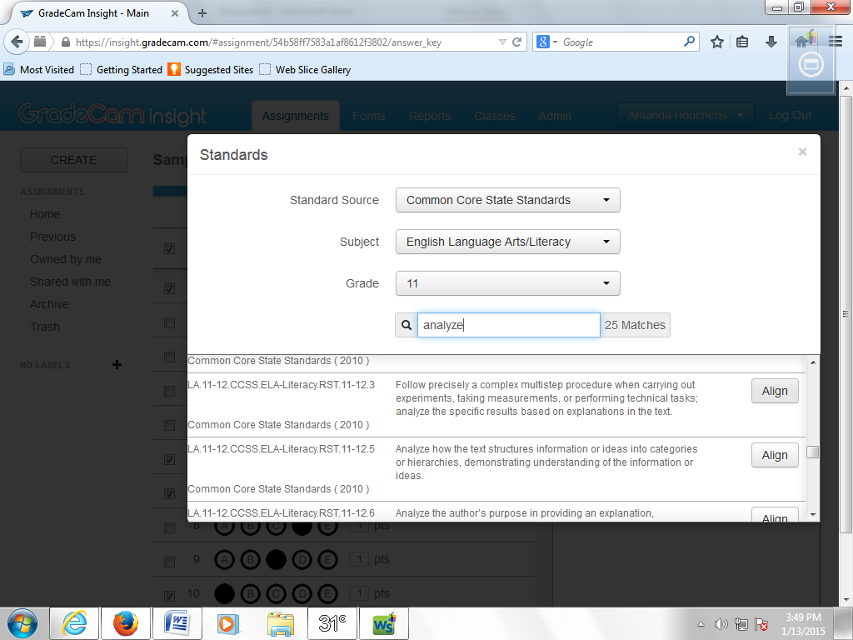

You will automatically be taken back to this screen and you should see the questions you selected aligned to the standard you selected. At this time, only one standard can be aligned to each question.
You are now ready to repeat this process until you have aligned all of the questions on your test to a standard.
Once this is done, you are ready to print your forms and score them as you have in the past.
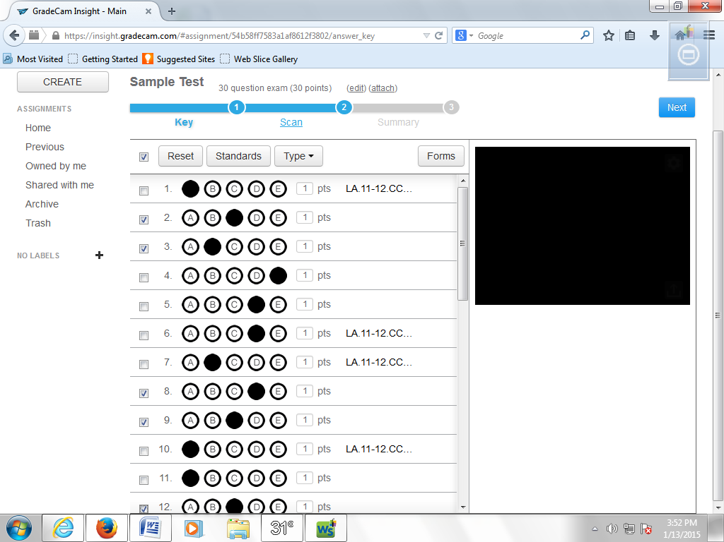

Now… How to access the wealth of knowledge you just obtained from your students test results?
From the home screen, select the “Reports” tab.
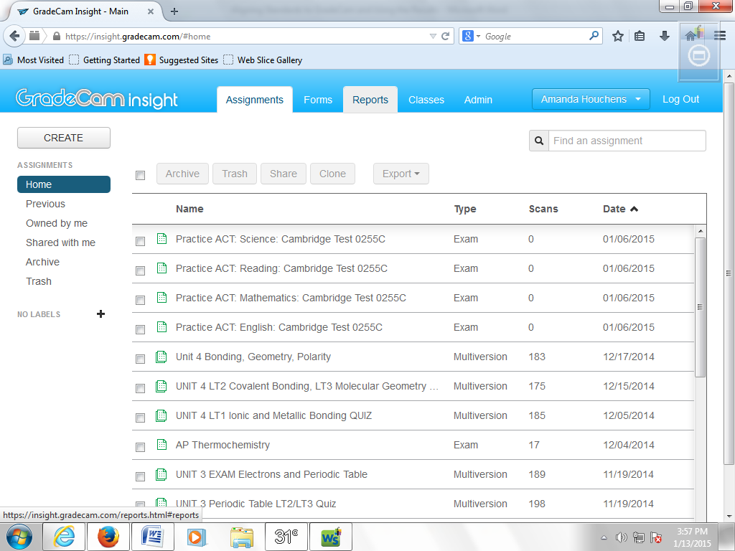

Then click the “Classes” link.
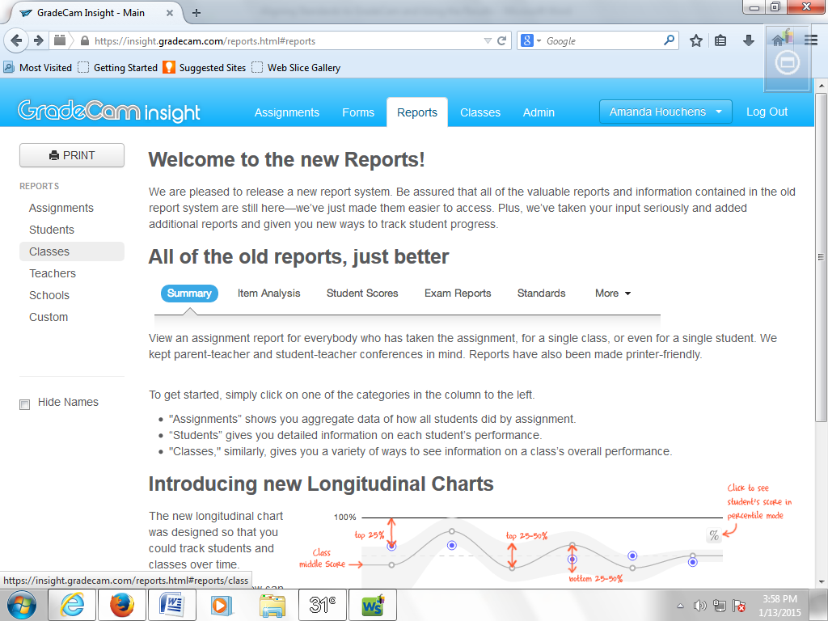

Then, select the class you wish to obtain results for.
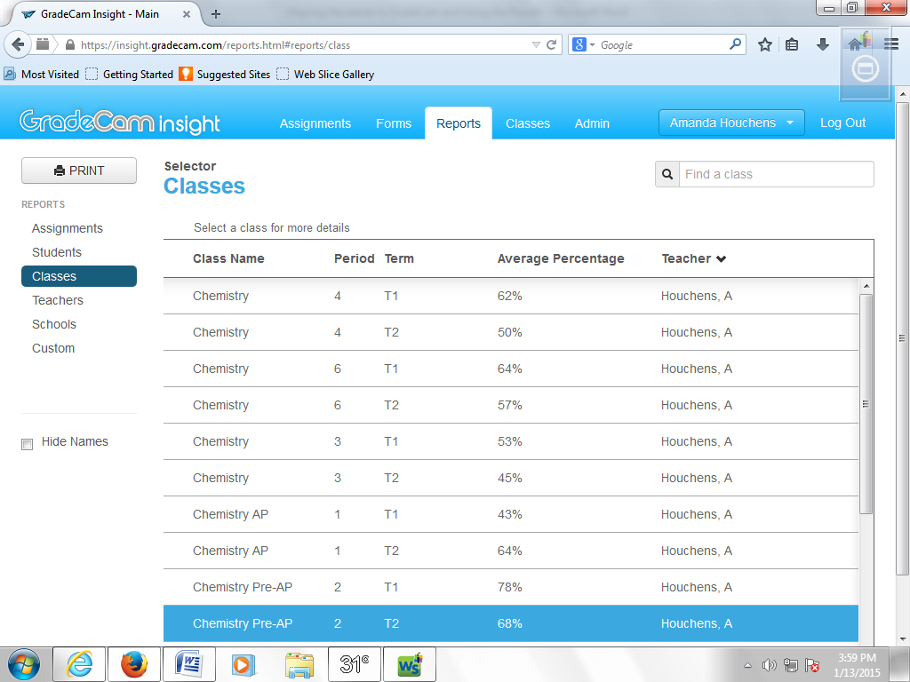

Then, select the assignment you wish to see the results for.
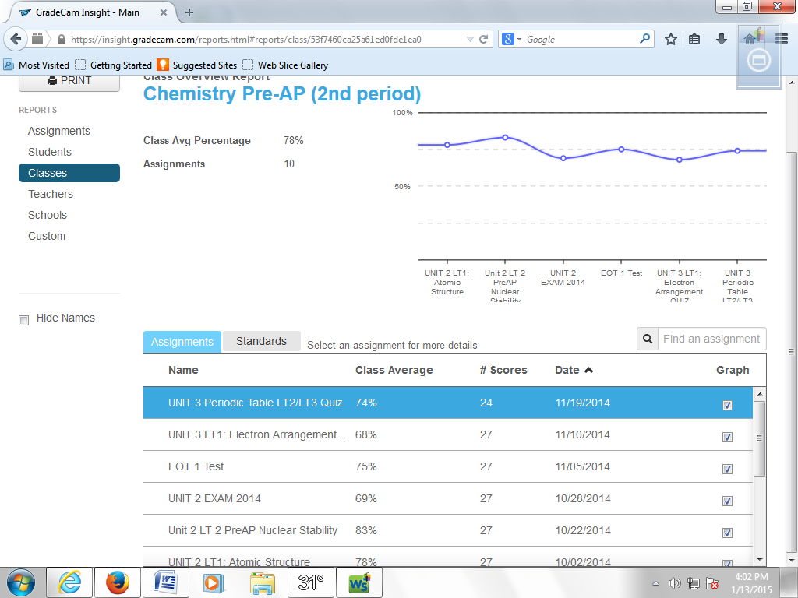

Once on this screen, there are a two things you need to do.
First, IF YOU HAD MULTIPLE VERSIONS OF THE EXAM, select “all” from the drop down menu on the right.
Second, click the “Standards” link.
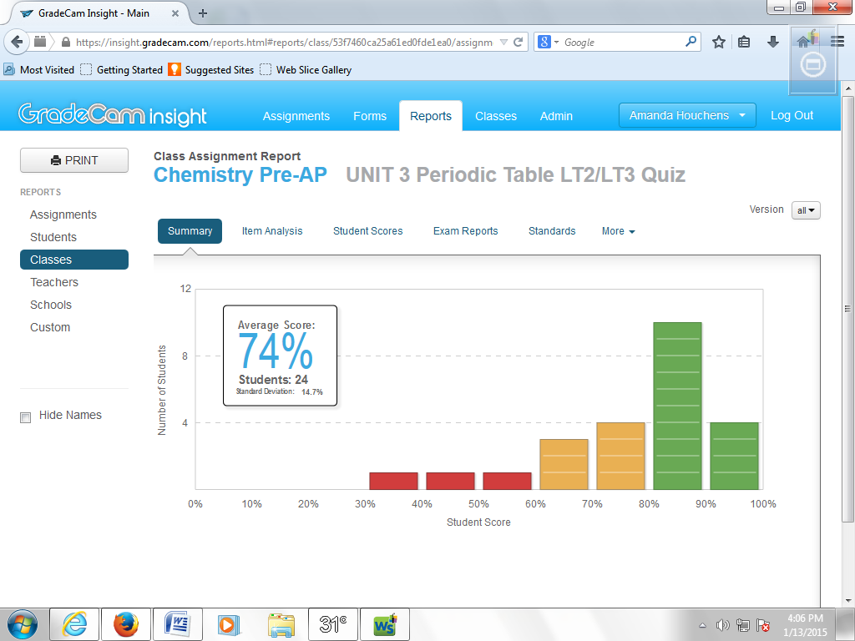

You should then see a screen with the standards you selected listed under the heading “Identifier” and a class average for each standard. If you want to see a breakdown by student, select “Students” from the drop down menu.
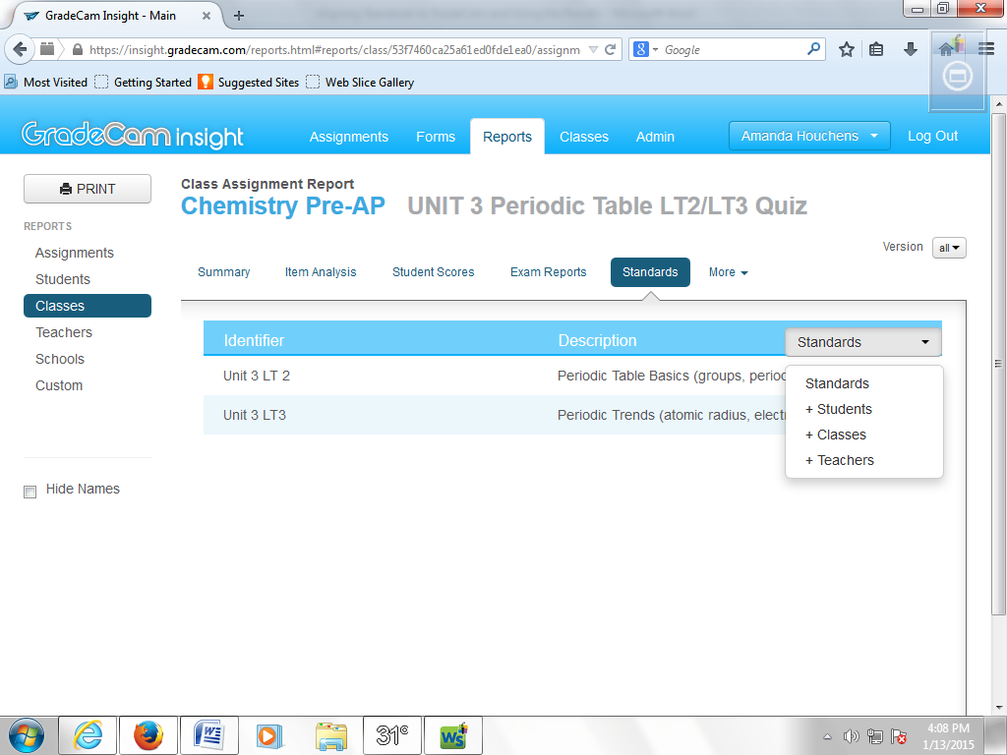

You will then see a screen you can scroll down that will show you each students percentage listed under each standard. There is even a print option on the screen if you need to print it.
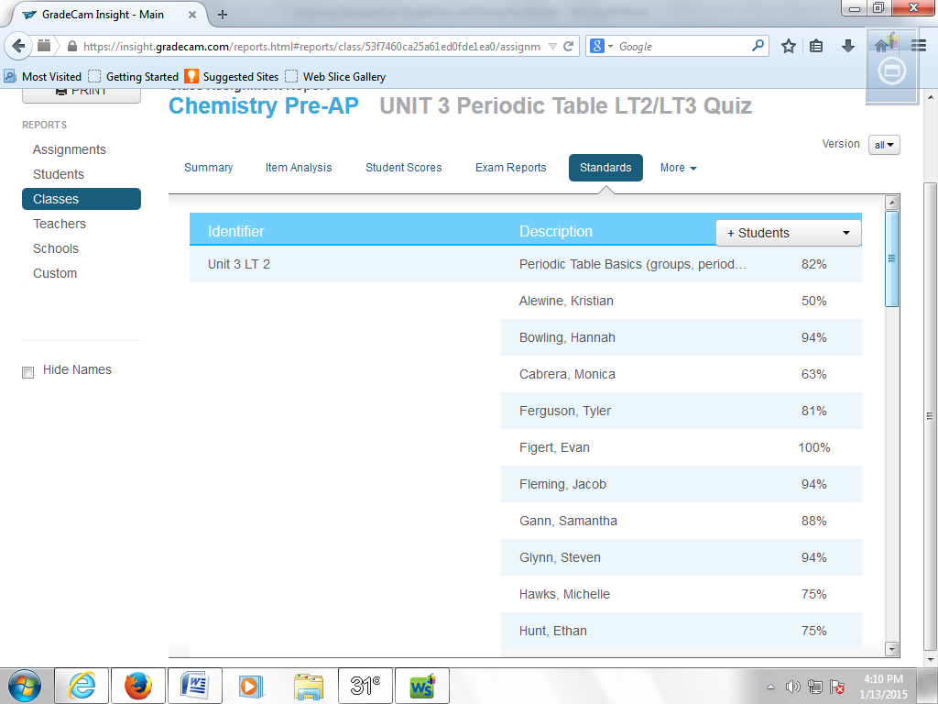

If you select “Students” from the drop-down menu under “More”…
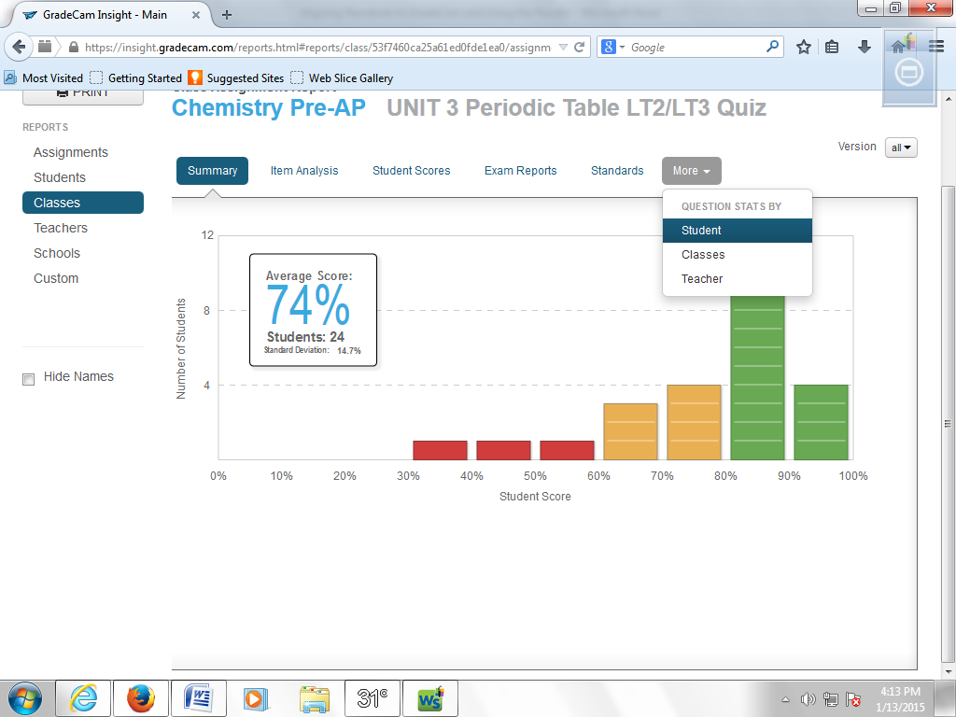
You get this helpful bit of info…
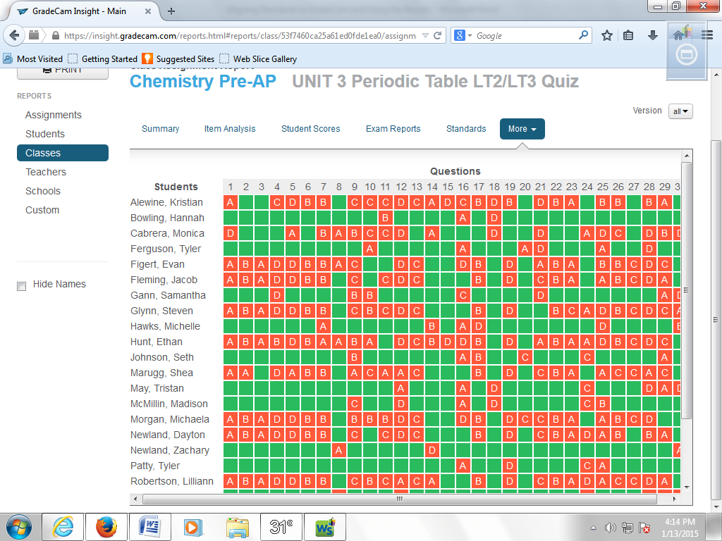

There are A TON of other great reports that you can easily access but it took forever to figure out how to get the standards breakdown by student report so Mrs. Reetzke asked me to create one of my “how-to” guides with pictures.
In the spirit of giving credit where credit is due, I want to make sure Mrs. Salyer gets the recognition for figuring out how to access this report and sharing it with me.

